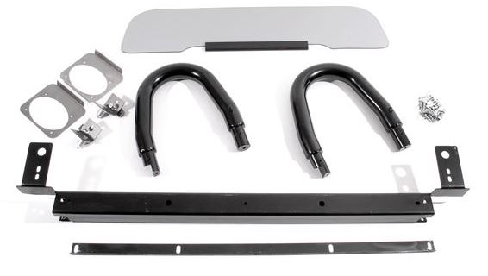
BOXER ROLLHOOP WINDSTOP
MGF TF

Part Number: RP1010B,
RP1020S & RP1020C

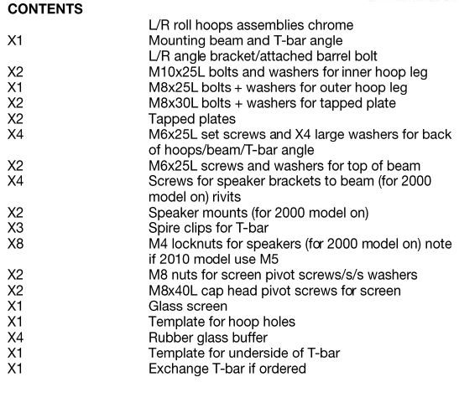
Step 1: Remove Existing Wind Break and T-Bar
Locate and remove the three screws securing the T-Bar in place.
Gently pull the T-Bar forward; it should release from little pegs.
Once removed, set aside the T-Bar.

Step 2: Unclip the Hood and Remove Speaker Box
From the inside of the car, unclip the hood.
Lift the hood cover at the back to facilitate the next steps.
If present, remove the speaker box by unscrewing the two screws at either end.

Step 3: Prepare for Hoop Installation
Secure the provided template from the kit to the back of the car using masking tape.
Carefully drill four holes through the template, ensuring accuracy.

Step 4: Modify Template and Prepare T-Bar
Trim the template to match the location of the hoops.
Using a sharp chisel or Dremel tool, remove excess material from the back of the template.
Use a hot glue gun to secure the T-Bar locating pegs in place.

Step 5: Enlarge Holes and Install Roll Hoops
Enlarge the holes in the car using a larger cutter.
Lubricate the roll hoops with silicone spray.
Carefully insert the roll hoops into the enlarged holes and secure them with provided screws and brackets.

Step 6: Repair Windbreak Hole
Use a plug cutter to create plugs from the removed material.
Apply hot glue to the hole and insert the plugs.
•Trim excess glue once it sets for a clean finish.

Step 7: Install Beam and Secure Components
Fit the beam into the car, ensuring it aligns with the holes in the turret.
Reconnect speakers, paying attention to wire colours for the left and right sides.
Secure wires to the beam using ties or tape.

Step 8: Install T-Bar and Seat Belts
Reinstall the T-Bar into its original position.
Attach seat belts, making sure they are not twisted.
Tighten screws securing the T-Bar and seat belts, ensuring a secure fit.

Step 9: Fit Glass Windbreak
install the glass windbreak between the roll hoops.
Adjust screws to centralize the glass.
Tighten lock nuts against the glass without touching it.
Set tension on the glass using washers and provided buffers.

Step 10: Final Checks and Adjustments
Ensure the alignment of the roll hoops and glass windbreak is correct.
Tighten all screws, nuts, and bolts securely.
Confirm proper tension on the glass windbreak, preventing any flopping or movement.

